**LAB # 02**



**Circuit and System Lab**

Submitted by:Maaz habib

Registration No. :20PWcse1952

Class Section:**C**

“On my honor, as student of University of Engineering and Technology, I have neither given nor received unauthorized assistance on this academic work.”

Submitted to:

**Engr. Fiaz ullah**

Month Day, Year (May,3, 2021)

Department of Computer Systems Engineering

University of Engineering and Technology, Peshawar

**Resistance:**

An act or instance of opposing. 2 : the ability to withstand the force or effect of **resistance** to disease. 3 : an opposing or slowing force The car's sleek design reduces wind **resistance**. 4 : the opposition offered by a substance to the passage through it of an electric current.

**Unit of Resistance:**

SI **unit** of **resistance** is Ohm (Ω). It is **resistance** offered by an object when 1 volt potential difference is applied across it and 1 Ampere of current passes through it

**Colour code** :

A **color code** or **colour code** is a system for displaying information by using different **colors**. The earliest examples of **color** codes in use are for long distance communication by use of flags, as in semaphore communication.

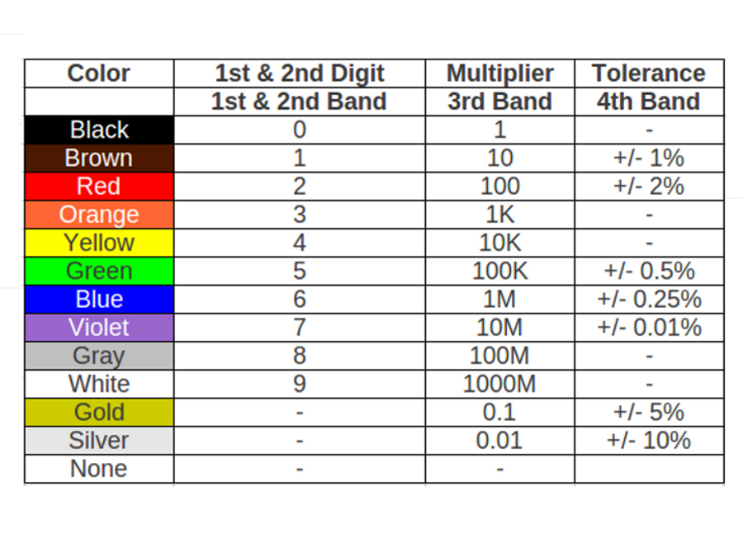

**Observation:**

|  |  |  |  |  |  |  |
| --- | --- | --- | --- | --- | --- | --- |
| S.No | 1st Band | 2nd Band | 3rd Band | 4 th Band  Toleranc | Resistance  (Color Code)  (Ω) | Range of resistance  (Ω) |
| 1 | **1** | **2** | **10** | **± 05 %** | **120** Ω | **114** Ω to 126 Ω |
| 2 | **3** | **0** | **100** | **± 05 %** | **1k** Ω | **2950** Ω to 3050 Ω |
| 3 | **1** | **1** | **1k** | **± 10 %** | **11k**Ω | **9.9k**Ω **to 12.1k** Ω |
| 4 | **4** | **7** | **1k** | **± 05 %** | **47k** Ω | **44.65k**Ω to 49.35k Ω |
| 5 | **7** | **9** | **10** | **± 10 %** | **790** Ω | **711** Ω to 869 Ω |